RESOLUTION NO.__________

RE: CERTIFICATE OF APPROPRIATENESS UNDER THE
PROVISIONS OF THE ACT OF THE PENNSYLVANIA
LEGISLATURE 1961, JUNE 13, P.L. 282 (53
SECTION 8004) AND BETHLEHEM ORDINANCE NO.
3952 AS AMENDED.

WHEREAS, it is proposed to replace the existing signage with new franchise signage at 25 E. Third Street.

NOW, THEREFORE, BE IT RESOLVED by the Council of the City of Bethlehem that a Certificate of Appropriateness is hereby granted for the work.

Sponsored by: (s)

(s)

ADOPTED BY COUNCIL THIS DAY OF

(s)
President of Council

ATTEST:

(s)
City Clerk

HISTORIC CONSERVATION COMMISSION

CASE # 552 – It is proposed to replace the existing signage with new franchise signage at 25 E. Third Street
OWNER/APPLICANT: Om Three, LLC/ Color Me Mine, Tara Nagabhyru

The Commission upon motion by Mr. Cornish seconded by Mr. Lousch adopted the proposal that City Council issue a Certificate of Appropriateness for the proposed work described herein:
- The proposal to replace the existing signage with new franchise signage and paint the logo/name on the back wall of the building at 25 E. Third Street was presented by Tara & Ravi Nagabhyru.
- The new signage will read “Color Me Mine” in individual letters attached to a MDO or metal back panel attached to the existing metal frame from the Home and Planet sign.
- The panel will be oval in shape and include a pinstripe border of yellow and green on a background color of gray several shades darker than the existing tile gray. The size of the oval back panel will be reduced in size as much as possible. The paint brush of the logo may protrude from the oval.
- The remaining structure from the Home and Planet sign, currently purple in color, may be painted dark green to blend with the color of the relocated sign.
- The relocated sign may be illuminated with 3 gooseneck lights coming up from the metal horizontal bars and arching over to shine on the sign. The gooseneck light fixtures will be the same or similar to the lights used at Molinari’s restaurant.
- The proposed rear sign as not approved at this time and will be brought back to HCC at a later date.
- The proposed motion was unanimously approved.

CU: cu
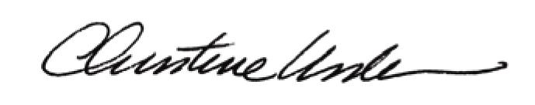

By:

Date of Meeting: May 18, 2015 Title: Historic Officer

